**Project Planning Phase**

**Project Planning Template (Product Backlog, Sprint Planning, Stories, Story points)**

|  |  |
| --- | --- |
| Date | 18 October 2022 |
| Team ID | PNT2022TMID48096 |
| Project Name | Signs with smart connectivity for better road safety |
| Maximum Marks | 8 Marks |

**Product Backlog, Sprint Schedule, and Estimation (4 Marks)**

Use the below template to create product backlog and sprint schedule

| **Sprint** | **Functional Requirement (Epic)** | **User Story Number** | **User Story / Task** | **Story Points** | **Priority** | **Team Members** |
| --- | --- | --- | --- | --- | --- | --- |
| Sprint-1 | Initialization of the resources | USN-1 | Create and open some accounts like Open weather API etc.. | 2 | Low | A.Rani praba  G.Pargavi  R.Abinaya  A.Revathi |
| Sprint-1 | Software used | USN-2 | Write a Python program that outputs results given the inputs like weather and location. | 1 | High | A.Rani praba  G.Pargavi  R.Abinaya  A.Revathi |
| Sprint-2 | Push the server to cloud | USN-3 | We use IBM cloud for project deployment | 2 | High | A.Rani praba  G.Pargavi  R.Abinaya  A.Revathi |
| Sprint-3 | Hardware -sensor | USN-4 | To sense the obstacles or to measure the parameters we need | 2 | Medium | A.Rani praba  G.Pargavi  R.Abinaya  A.Revathi |
| Sprint-3 | Buzzer |  | It gives alarm when the vehicle’s speed is above the limited speed | 1 | High | A.Rani praba  G.Pargavi  R.Abinaya  A.Revathi |
| Sprint-4 | Optimization and debugging | USN-5 | Enhance the performance and provide better user experience |  | High | A.Rani praba  G.Pargavi  R.Abinaya  A.Revathi |

**Project Tracker, Velocity & Burndown Chart: (4 Marks)**

| **Sprint** | **Total Story Points** | **Duration** | **Sprint Start Date** | **Sprint End Date (Planned)** | **Story Points Completed (as on Planned End Date)** | **Sprint Release Date (Actual)** |
| --- | --- | --- | --- | --- | --- | --- |
| Sprint-1 | 20 | 6 Days | 24 Oct 2022 | 29 Oct 2022 | 20 | 29 Oct 2022 |
| Sprint-2 | 20 | 6 Days | 31 Oct 2022 | 05 Nov 2022 | 20 | 05 Nov 2022 |
| Sprint-3 | 20 | 6 Days | 07 Nov 2022 | 12 Nov 2022 | 20 | 12 Nov 2022 |
| Sprint-4 | 20 | 6 Days | 14 Nov 2022 | 19 Nov 2022 | 20 | 19 Nov 2022 |

**Velocity:**

Imagine we have a 10-day sprint duration, and the velocity of the team is 20 (points per sprint). Let’s calculate the team’s average velocity (AV) per iteration unit (story points per day)

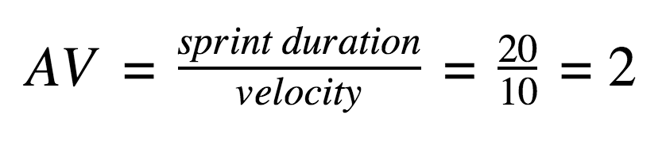

**Burndown Chart:**

